Lab 6 - Deep Learning Lab Report

Introduction
In this lab, we will practice implementing and applying deep learning approaches discussed in class. You will gain practical skills in evaluating and improving deep learning model performance. Unlike other labs, where you submitted a Jupyter Notebook file, you will continuously improve your own code and submit this report instead.
Lab Objectives:
- Understand the fundamentals of PyTorch Lightning for tabular data modeling.
- Run and analyze a baseline model using TensorBoard logs.
- Experiment with different batch sizes, model architectures, and learning rate schedulers to optimize training.

Part 1: Baseline Code
Begin by downloading and reviewing the provided PyTorch Lightning script from Canvas. This script implements a simple pipeline for training a neural network on tabular data. The dataset we will be using is the Forest Cover dataset, which provides 54 different features about forest conditions and 7 target classifications for the density of cover in that forest.
To start this lab, simply get the original script running. It is provided in straight Python code and as a Jupyter Notebook for convenience (Note: Dr. Hart has had experiences in the past where PyTorch freezes on Jupyter).
Getting the original script may require setting up your Python environment with PyTorch and installing needed packages for PyTorch Lightning and Tensorboard. On a machine with reasonable specs, a full loop through the training data should take under a minute, even on a CPU. If you are having difficulty getting the code to train an epoch in under a minute, please discuss options with Dr. Hart.
After completing the first full training run, note the final testing accuracy and the training time (you can add Python’s time library for convenience). Next, run Tensorboard to see the training loss and validation accuracy graphs. To run Tensorboard, use the terminal command:
tensorboard --logdir my_logs/
Take a screenshot of the training loss and validation graphs and place them in this report. This will serve as a reference for later parts of the assignment.
Testing Accuracy: 70.369% | Training Time: 72 seconds
Training Loss Graph:
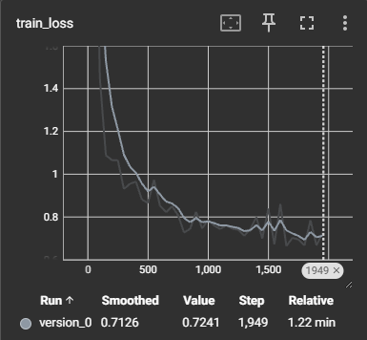
Validation Accuracy Graph:
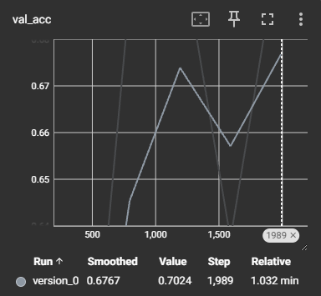

Part 2: Data Preprocessing
We have discussed this point many times before, but properly preprocessing the data can significantly improve model performance. In particular, deep learning models can be sensitive to data scaling. Most models can eventually converge without data scaling, but you can save a lot of training time by incorporating it.
For this part of the lab, analyze the Forest Cover dataset to understand how the data should be scaled or preprocessed. Implement the changes you determine are needed. You can use sklearn preprocessing functions if they are helpful.
After implementing the changes, rerun the training loop and record the new testing accuracy. Fill out the report cells and answer the questions below.
Implemented Changes: Collapsed Wilderness_Area and Soil_Type columns into just two features, scaled other features
New Testing Accuracy: 74.551%
Question Response – Were you surprised by how much the accuracy changed after scaling? Why do you think MLPs can be sensitive to the scale of the input data?
No, it didn’t increase as much as I was expecting but still increased by about 4 percent. MLPs can be sensitive to scaling input data because scaling the data makes each features’ attribution to gradients equal.

Part 3: Exploring Architectures
The neural network architecture determines the number of parameters in the model. Finding the right architecture for the complexity of the problem can increase the convergence accuracy and speed.
Modify the MLP architecture to include hidden parameter sizes and number of layers. Try configurations varying from very small to very large to try to gain intuition about the effects of architecture to accuracy. Try at least 5 different configurations of hidden layers and sizes. Fill out the table below as you do (recommend configurations included).
Configuration | Testing Accuracy | Training Time
[64, 32] | 74.18224811553955% | 44.421 seconds
[64, 128, 64] | 76.16842985153198% | 49.118 seconds
[64] | 73.62805008888245% | 45.617 seconds
[128, 64, 32] | 75.987708568573% | 52.719 seconds
[256, 128] | 76.76566243171692% | 55.523 seconds
[512, 256, 128] | 78.47215533256531% | 72.306 seconds
[1024, 512, 256, 128] | 79.84733581542969% | 126.685 seconds
[1024, 512, 256] | 79.75439429283142% | 127.689 seconds
[4096, 2048, 1024] | 79.37316298484802% | 1038.783 seconds
[1024, 512, 256, 128, 64,32] | 78.11071872711182% | 128.278 seconds
[1024, 512, 256, 128, 64] | 79.35337424278259% | 130.286 seconds
I then ran a for loop to test all in-order combinations starting from [16] to [16,32,64,128,256,512,1024] (ex: [64,128,256]) to find the best architecture with the highest accuracy. The below is the best I found from doing this.
[64, 128, 256, 512, 1024] | 84.1320812702179% | 143.77 seconds
Question Response – What configuration ended up working the best? Did you see a point where increasing dimensions or layers stopped improving accuracy? Did you see any trade-offs in training time?
The configuration that had the highest testing accuracy was [64,128,256,512,1024] with 84.13%. I wasn’t able to pinpoint where more layers stopped improving accuracy enough to bother, but I did notice that more layers and especially larger layer sizes increased training time but did not produce great enough accuracy to make-up for the time spent.

Part 4: Batch Size
Now that you have found a good architecture, lets configure the optimizer and training loop. There are a lot of hyperparameters associated with the optimization of a neural network, including batch size, epochs, and learning rate. We’ve discussed some of these principles in class, but building intuition of how to modify these comes with practice and exploration.
Let’s start with batch size. A good batch size can improve training speed and increase performance. If the batch is too small, it will be slow to train and too noisy between samples. If the batch is too large, it may not learn as well because of over-averaging the loss values. Try to find the sweet spot. Try at least 4 batch sizes ranging from very small to very large.
Batch Size |  | Testing Accuracy |  | Training Time
64 | 88.13% |  | 648.00 seconds
128 | 89.43% |  | 421.29 seconds
256 | 88.52% |  | 274.02 seconds
512 | 86.53% |  | 189.17 seconds
1024 | 82.72% |  | 155.35 seconds
2048 | 80.55% |  | 148.34 seconds

Part 5: Max Epochs
If you have a good validation dataset and checkpointing, training for longer should always provide better results. At some point, however, the network stops making meaningful improvements. While there are automatic ways to detect this point, gaining an understanding of how long you should expect something to train is helpful. Run the network for 500 epochs and watch the validation accuracy curve in Tensorboard. See if you can determine when the appropriate number of training epochs has been reached at this learning rate. Paste your training loss graph and validation accuracy graph from Tensorboard in the space below.
Training Loss Graph:
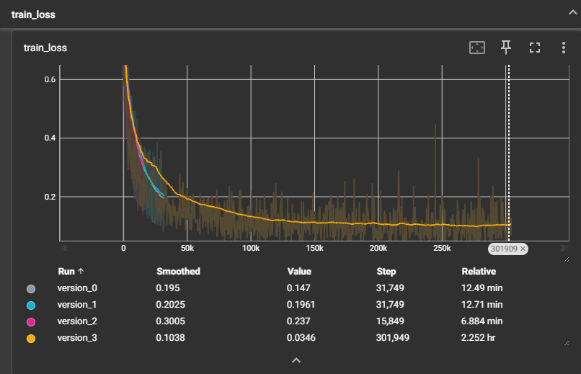
Validation Accuracy Graph:
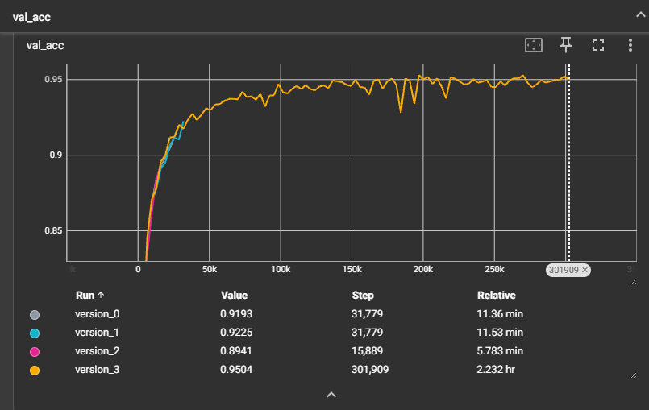
Question Response – What do you think is an appropriate number of training epochs for this particular problem? What information did you use to come to this conclusion?
I believe the right number of epochs for this problem is 30. The training loss and validation accuracy graphs start to plateau at about the 100k step mark, which was within the 30th epoch in my testing. If time is an issue, 15 epochs is at the 50k step mark and is not much less accurate.

Part 6: Learning Rates and Scheduler
The learning rate can have a drastic effect on the stability and result of the gradient descent optimization. Picking a good learning rate is essential to training deep learning models. Additionally, learning rates can also be changed during the training process, allowing for even better solutions to be found quickly.
For this part of the lab, train your model with the different learning rates listed in the table below. Additionally, try at least one run with a learning rate scheduler. For example, to multiply the learning rate by a factor of 1/10 (0.001, 0.0001, 0.00001, etc.) after every 10 epochs, use the following code:
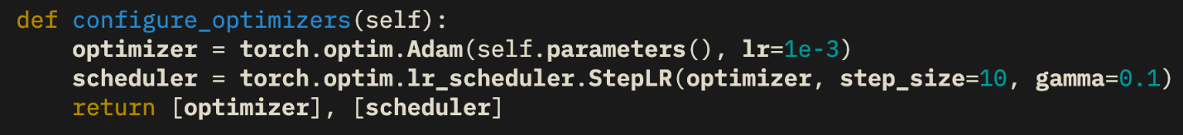
You may adjust the step_size parameter or try other schedulers if you wish.
Learning Rate/Schedule | Step Size | Testing Accuracy | Training Time
1e-2 | 10 | 78.03% | 1748.78 seconds
1e-2 (w/ SS2) | 10 | 78.07% | 1477.07 seconds
1e-3 | 10 | 92.82% | 1515.19 seconds
1e-3 (w/ SS) | 5 | 94.23% | 821.01 seconds
1e-3 (w/ SS) | 10 | 92.09% | 792.94 seconds
1e-3 (w/ SS2) | 10 | 95.25% | 1274.39 seconds
1e-3 (w/ SS) | 25 | 91.78% | 786.28 seconds
1e-4 | 10 | 86.39% | 1263.43 seconds
1e-4 (w/ SS) | 5 | 80.68% | 751.52 seconds
1e-4 (w/ SS) | 10 | 84.44% | 723.27 seconds
1e-4 (w/ SS2) | 10 | 85.96% | 1366.55 seconds
1e-4 (w/ SS) | 25 | 84.26% | 745.54 seconds
1e-5 | 10 | 75.57% | 1654.21 seconds
1e-5 (w/ SS) | 5 | 72.37% | 780.29 seconds
1e-5 (w/ SS) | 10 | 73.78% | 729.56 seconds
1e-5 (w/ SS) | 25 | 73.89% | 757.50 seconds
Question Response – What learning rate scheduler worked best? Did you notice any differences on how the different learning rates converged to a solution? What process will you use to set the learning rate on future problems?
A learning rate of 0.001 (1e-3) using the StepLR scheduler worked best returning the highest accuracies. Other learning rates such as 1e-2 and 1e-4 achieved less accuracy. I will set the learning rate using the optimizer and step scheduler.

Part 7: Final Model
You now have experimented with the various hyperparameters and components you can modify in a deep learning pipeline. Now, it’s time to explore and train the best model you can. Make any modifications to configuration that you see fit. Try to obtain as high a testing accuracy as possible on this problem. List your final configuration below:
Architecture | Batch Size | Epochs | Learning Rate/ Scheduler | Other Changes | Testing Accuracy | Training Time
[64,128,256,512,1024] | 128 | 25 | 1e-3 /StepLR | Step Size 11 | 96.29% | 1854 seconds
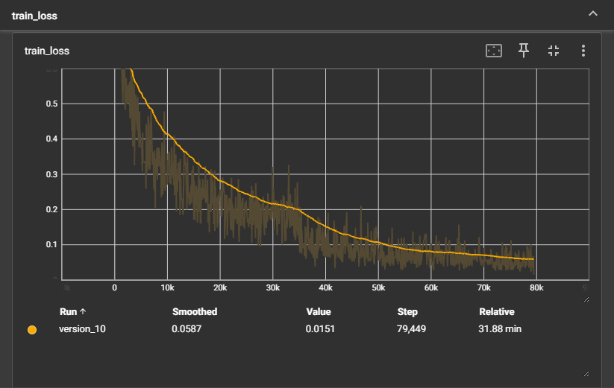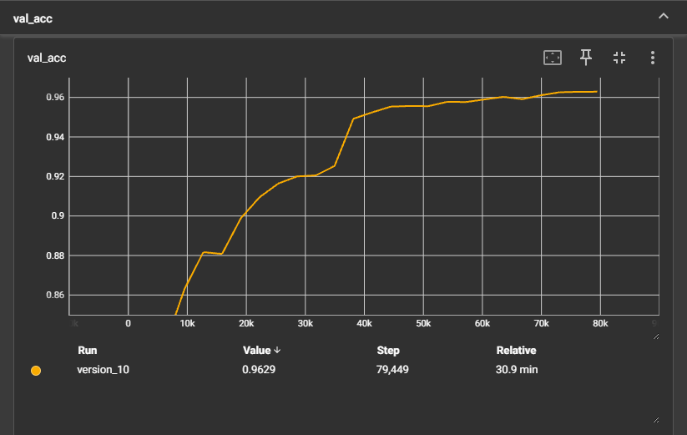
As a fun bonus, the student with the highest final testing accuracy will receive extra credit.

Submission Instructions
Once you have completed all the experiments listed in this document, submit on Canvas
- This completed word document
- The final version of your code that achieved the best test accuracy
Warning: Please do not submit the forest_cover.csv file. Students that do so may be docked points for not following instructions.
Good luck! Experiment boldly, record thoroughly, and reflect thoughtfully. Your hands-on work here will help you master practical machine learning optimization.

